Empathize

In this step we tried to understand the needs, pain points and motivations of our target users. We used the scenarios given in the project description to find these. For each scenario we found what the person is saying, thinking, doing, and feeling. The results are given below -

Sarah (Overwhelmed Financial Analyst):

* Says: "I spend countless hours manually combing through documents.", "I have little time for in-depth analysis."
* Thinks: "There must be a more efficient way to do this.", "I wish I had more time to provide strategic insights.", "Am I missing any critical details?"
* Does: Extracts figures manually, creates presentations, feels rushed.
* Feels: Overwhelmed, stressed, frustrated, time-constrained.

Empathy Map for Sarah:

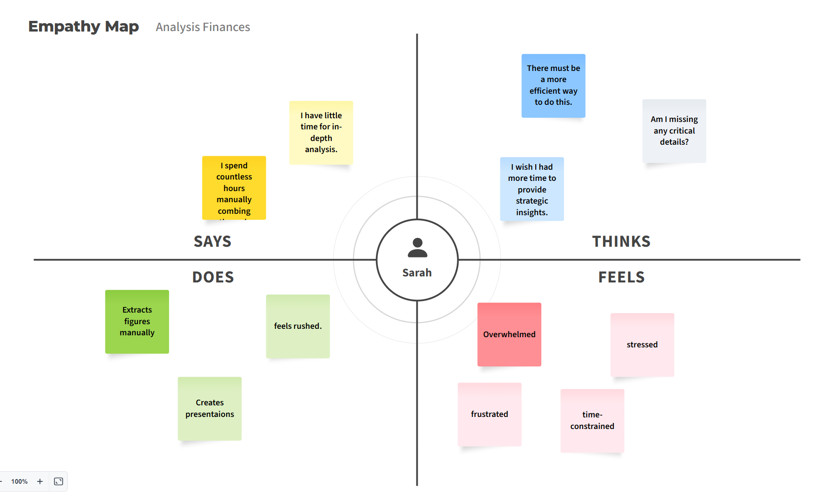

Rajesh (Non-Financial CEO):

* Says: "I find the jargon and complex tables difficult to decipher."
* Thinks: "What does this actually mean for my business?", "Am I making the right decisions based on this?", "I need to understand this quickly."
* Does: Skims reports, asks for clarification, makes slower decisions.
* Feels: Confused, frustrated, lacking confidence in financial understanding.

Mark (Time-Sensitive Financial Journalist):

* Says: "I need to quickly analyze results to write an article before my deadline.", "I worry about missing critical details."
* Thinks: "How can I get the essential information fast?", "Is my reporting accurate and comprehensive?"
* Does: Manually reviews lengthy statements, rushes analysis.
* Feels: Pressured, anxious, concerned about accuracy and missing deadlines.